Everyone at Phoenix Male Voice Choir is saddened by the recent news
that two of our Bass 1 Singing Friends have passed away:

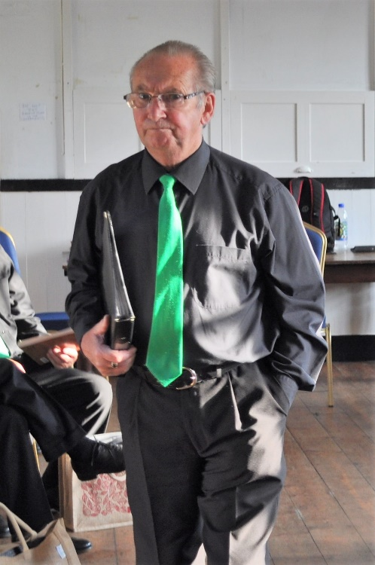
David North – Bass 1 Chorister and Long-serving Committee Member
David’s association with Phoenix was as long as the Choir is old. He appeared at our inaugural Mile Cross concert in July 2010, and served for the years since as a member of the Choir’s Management Committee. Consequently, his guidance and support ensured the Choir’s early survival and its later growth.

His contribution to our first decade was therefore invaluable and he will be equally remembered as a personable ever-present in our Bass 1 ranks over the years.

As we resumed and expanded our activities following the Covid-19 lockdowns, David’s health had become more fragile and he sadly had to withdraw from both singing and committee roles with us. However, he had by then more than fully made his respected mark in the history of our Choir. We send our deepest condolences on David’s passing to his daughter Carolyn, and all members of David’s family and his wider circle of friends.

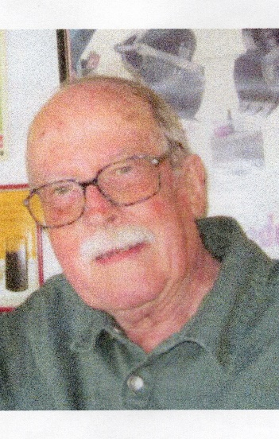
Robin Morris – Bass 1 Chorister
Robin was a very much more recent recruit to our ranks, but valued since as a Choir Member, having joined us in June 2022 following the Choir’s very successful Open Rehearsal period at the beginning of our Summer Season that year.

However, intermittent spells of poorer health since then frustratingly prevented him from taking the full part in the Choir he had hoped for and often talked about being able to enjoy. He was nonetheless a welcome audience member at our Concerts when not able to join us onstage and rehearsals were always better for his presence.

With us for too short a while, Robin will be remembered for his enthusiasm for singing, which was obvious to all of us. We send our deepest sympathies on Robin’s passing to his wife Carol, and his wider circle of family and friends.

Both David and Robin are now named among our late Singing Friends
we remember with affection. May they both rest in peace.

