Norwich Evening News > Things to do

'It's great fun and good for health' - Male voice choir seeks new members

Ian Clarke
Published: 7:22 AM April 3, 2022
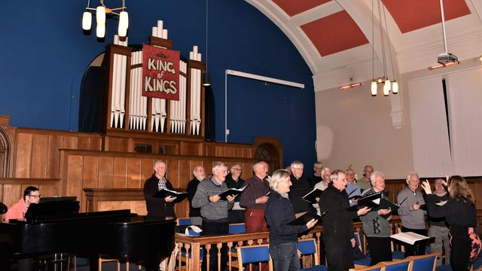
Norwich Phoenix Male Voice Choir. - Credit: Phoenix Male Voice Choir
One of the East of England’s few male voice choirs is looking to recruit new voices.
The Phoenix Male Voice Choir – which rehearses on Thursday evenings at the Mile Cross Methodist Church in Norwich – was created in 2010 by musical director Sarah Sheldrake.
Now Sarah Grimes, she continues to lead the choir which has performed more than 40 concerts in the county and beyond.
The choir features songs from the shows, numbers from the Great American songbook and also performs marches and hymns in a style reminiscent of the famous Welsh male voice choirs.
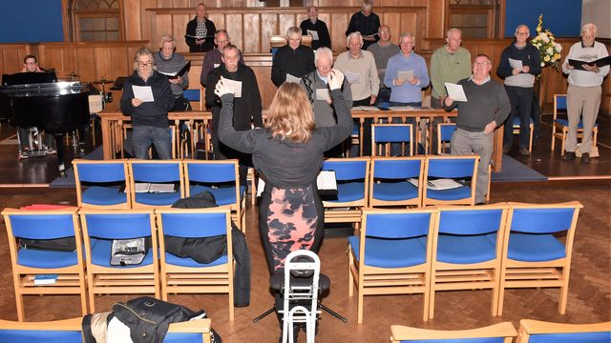
Phoenix Male Voice Choir - Credit: Phoenix Male Voice Choir
The choir is looking to recruit new male singers in either tenor or bass voice ranges to join them for rehearsals for a summer concert.
They will be holding an open rehearsal on Thursday April 28, while an ability to read music would be helpful, it is not essential.
The choir’s newly elected chairman is Jerry Elliott, who answered a similar appeal in 2015 and said: “It is an honour and privilege to become chairman of Phoenix MVC.”
"I really enjoy singing with them, it's great fun and is good for one’s health, both physically and mentally.”
He also praised the work of the outgoing chairman, broadcaster and University of East Anglia lecturer Ian Masters, who remains a choir member.
Phoenix MVC have three concerts planned this year, the next being a spring concert at Mile Cross Methodist Church on Saturday April 9, 7.30pm.
Mr Elliott said: "Come along and see what we are all about. Our limited concert programme for 2022 takes into account the ongoing health and wellbeing of our members, professional musicians, volunteers and audience and remains of paramount concern to us and is uppermost in our minds."
For further information go to the website www.norwichphoenixmvc.org.
Anyone interested should contact Mr Elliott via email jeremyelliott189@gmail.com.
Norwich News

